Smart Crop Protection System From Animals PIC

Crops in farms are many times ravaged by local animals like buffaloes, cows, goats, birds etc. This leads to huge losses for the farmers. It is not possible for farmers to barricade entire fields or stay on field 24 hours and guard it. So here we propose automatic crop protection system from animals. This is a microcontroller based system using PIC family microcontroller. This system uses a motion sensor to detect wild animals approaching near the field. In such a case the sensor signals the microcontroller to take action.
The microcontroller now sounds an alarm to woo the animals away from the field as well as sends sms to the farmer so that he may know about the issue and come to the spot in case the animals don’t turn away by the alarm. This ensures complete safety of crops from animals thus protecting the farmer’s loss.

Block Diagram:

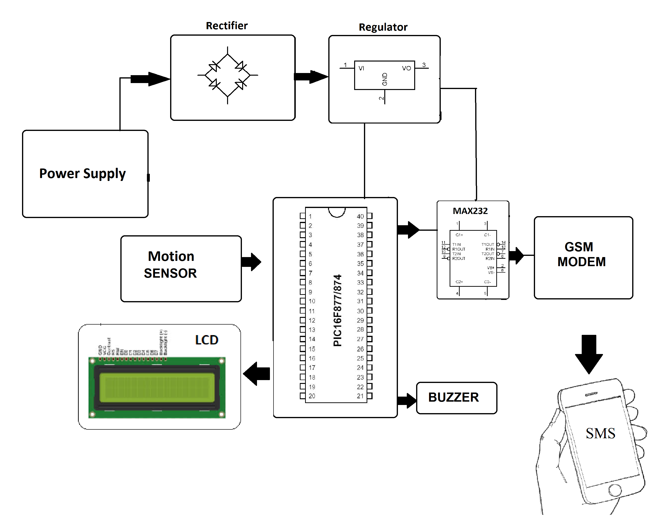

Hardware Specifications

- PIC Microcontroller

- Buzzer
- GSM Module

- LCD Display

- Crystal Oscillator
- Resistors

- Capacitors

- Transistors
- Cables and Connectors

- Diodes

- PCB and Breadboards
- LED

- Transformer/Adapter

- Push Buttons
- Switch

- IC

- IC Sockets
Software Specifications

- MPLAB

- MC Programming Language: C

